##### 

| Course Title | Introduction to Engineering |
| --- | --- |
| Course Code | CEN 100 |
| Semester/Year | Fall 2021 |
| Section Number | 29 |
| Group Number | 84 |
| GA & PM | Shereen Al Tamimi & Suhasee Patel |

| **Reverse Engineering Proposal** THE SAFE TAXI | |
| --- | --- |

| Submission Date | November 17, 2021 |
| --- | --- |

| Student Name | Student ID | Signature* |
| --- | --- | --- |
| Emmily Tse | 501100836 |  |
| Joaquin Katoka | 501104688 |  |
| Luxsika Sinnarasa | 501105669 |  |
| Adrian Parungao | 501102077 |  |
| Kartike Chaudhari | 501118313 |  |
| Tejveer Goga | 501088306 |  |
| Bilal Asghar | 501113295 |  |
| Evan Fekete | 501122435 |  |
| Hamza Ejaz Malik | 501112545 |  |

*\*By signing above you attest that you have contributed to this submission and confirm that all work you have contributed to this submission is your own work. Any suspicion of copying or plagiarism in this work will result in an investigation of Academic Misconduct and may result in a “0” on the work, an “F” in the course, or possibly more severe penalties, as well as a Disciplinary Notice on your academic record under the Student Code of Academic Conduct, which can be found online at:* [*http://www.ryerson.ca/senate/policies/pol60.pdf*](http://www.ryerson.ca/senate/policies/pol60.pdf)*.*

**Proposal - The Safe Taxi**

Taxis and Ubers are an integral part of life in the modern age. Allowing for people to easily and conveniently travel long and short distances. The problem it solves is it allows for people who do not have access to their own personal vehicle to still have access to quick and easy transportation. This problem is worth solving due to the fact that a very large portion of the population (typically teens to young adults) do not have access to their own cars and still need to travel. They also serve the purpose of putting less cars on the road allowing for a reduction in carbon emissions. Although in the modern day it is clear that Taxis are not Covid-19 ideal. This is because Taxis have not evolved for the Covid-19 Pandemic. Your average car space can be compared to one tenth of a bedroom space. It is very easy to transmit the disease as it only takes one passenger with Covid to do so. This has been proven to be a threat, the SAGE Environmental and Modelling group found that Covid-19 can and has been spread from public transportation including taxis. Public Health Ontario also found that public transport in Toronto declined by 71% from March 8th to March 30th 2020, although this number might have decreased, it shows people want a safer solution.

Our idea is to design a special car that prevents and takes all measures to keep passengers and drivers safe. We believe that such a design will prove to be integral to a safe and seamless transition to normalcy as we exit the pandemic. The Safe Taxi is a new model of car which implements many Covid safety features. One of the implementations we intend to add is replaceable seats. These seats are designed for one time use and cover the entire seat. This feature allows the passenger to not have to worry about the germs and bacteria carried by passengers before them. Other implementations in the product include a Contactless Payment Option, where passengers can pay for the service through an app to avoid having to touch anything in the car. A shield between the passenger and the driver which acts as a barrier blocking bacteria and germs, this also includes a sophisticated separate ventilation system to further block bacteria and germs while also allowing the use of Air Conditioning and Heating. Another very important feature is the addition of ultraviolet lighting that will help with detecting and disinfecting the interior of the vehicle. Furthermore, more strict protocols will need to be set by the driver such as keeping masks on at all times and sanitizing the back of the car every time a new passenger rides.

Our strategy is to separate the work evenly amongst students, whilst consulting other members when needed. We also meet two times a week to check in with each other. This is shown in our Breakdown of Duties and Schedule below.

**Breakdown of the Division of Work & Schedule for Project Completion**

| **Task** | **Owners** | **Due Date** |
| --- | --- | --- |
| Team Contract | All | 11/9/21 |
| Background (Proposal Project) | Luxsika, Adrian, Evan | 11/17/21 |
| Proposal (Proposal Project) | Kartike, Tejveer, Bilal | 11/17/21 |
| Milestones with date & division of work (Proposal Project) | Hamza, Joaquin, Emmily | 11/17/21 |
| References (Proposal Project) | All | 11/17/21 |
| Abstract  (Final report) | Kartike, Evan | 11/21/21 |
| Introduction  (Final report) | Kartike, Luxsika, Emmily | 11/21/21 |
| Background  (Final report) | Bilal, Hamza, Tejveer | 11/21/21 |
| Evaluation  (Final report) | Evan, Adrian, Hamza | 11/21/21 |
| User Experience  (Final report) | Adrian, Bilal, Joaquin | 11/21/21 |
| Re-Design Proposal  (Final report) | All | 11/21/21 |
| 1st Iteration  (Final report) | Luxsika, Evan, Kartike | 11/19/21 |
| 2nd Iteration  (Final report) | Bilal, Adrian, Emmily | 11/20/21 |
| 3rd Iteration  (Final report) | Hamza, Joaquin, Tejveer | 11/21/21 |
| Marketing  (Final report) | Kartike, Luxsika, Emmily | 11/21/21 |
| References | All | 11/21/21 |
| Introduction  (Presentation) | Kartike, Luxsika, Emmily | 11/23/21 |
| Background  (Presentation) | Bilal, Hamza, Tejveer | 11/23/21 |
| Current uses  (Presentation) | Evan, Adrian, Joaquin | 11/23/21 |
| Limitations (Presentation) | Bilal, Hamza, Tejveer | 11/23/21 |
| 1st Iteration  (Presentation) | Luxsika, Evan, Kartike | 11/23/21 |
| 2nd Iteration  (Presentation) | Bilal, Adrian, Emmily | 11/23/21 |
| 3rd Iteration  (Presentation) | Hamza, Joaquin, Tejveer | 11/23/21 |
| Complete Peer Feedback Survey  (Feedback) | All | 11/24/21 |

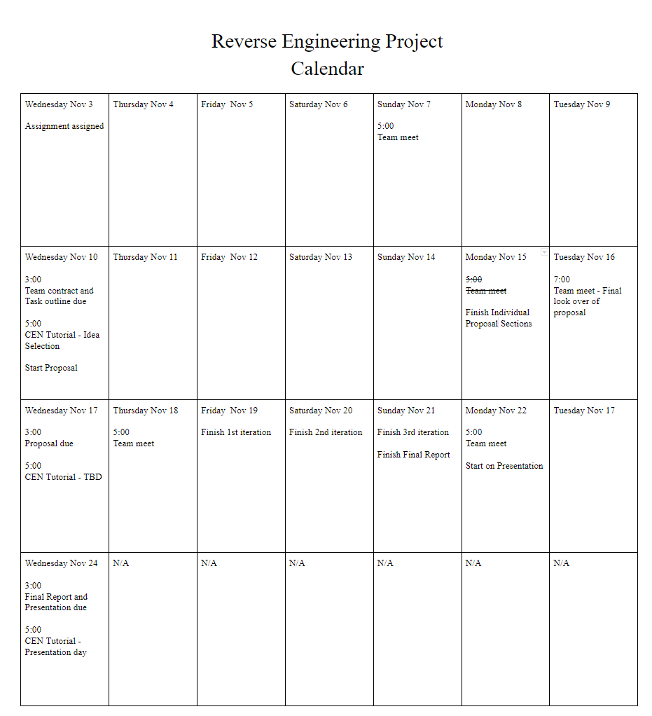

Work Cited:

[1] “Evidence for transmission of SARS-COV-2 on ground public ...” [Online]. Available: https://assets.publishing.service.gov.uk/government/uploads/system/uploads/attachment_data/file/904663/S0441_EMG_-_Evidence_for_transmission_of_SARS-COV-2_on_ground_public_transport.pdf. [Accessed: 17-Nov-2021].

[2] “Public transport and covid-19 – what we know so far.” [Online]. Available: https://www.publichealthontario.ca/-/media/documents/ncov/covid-wwksf/2020/12/what-we-know-covid-public-transport.pdf?la=en. [Accessed: 17-Nov-2021].